**DAV HZL SR. SEC. SCHOOL, DARIBA**

**TENTATIVE CO-CURRICULAR ACTIVITIES 2024-25**

|  |  |  |
| --- | --- | --- |
| **Date** | **Class** | **Activity (Events)** |
| 06/04/2024 | III TO V | Cinematic Odyssey: Arya Samaj Chronicles |
| VI TO VIII | Narrative Alchemy: Crafting English Tales |
| IX TO XII | Lens Enchantment: Interclass Cinematic Journey |
| 20/04/2024 | III TO V | Soliloquy Symphony: Mastering English Monologues |
| VI TO VIII | Dramatic Flourish: Theatrical Skits in English |
| IX TO XII | Electoral Insights: Interclass PowerPoint Showdown |
| 04/05/2024 | III TO V | Artistry Unleashed: Collage Creation Extravaganza |
| VI TO VIII | Sculpting Stories: From Clay to Chronicle |
| IX TO XI | Pixel Perfection: Design Delights with Photoshop |
| 05/07/2024 | III TO VIII | Green Horizon: Plantation Expedition |
| 06/07/2024 | III TO V | Calligraphy |
| VI TO X | Echoes of Ecology: English Environmental Orations |
| 11/07/2024 | III TO XII | Leadership Unveiled: Investiture Spectacular |
| 20/07/2024 | III TO V | Lexical Showdown: Spellbinding Spell Bee |
| VI TO VII | Verbal Voyage: Vocabulary Ventures |
| IX TO XI | Enlightening Discourse: TED Talk Showdown |
| 03/08/2024 | III TO V | Culinary Chronicles: Fireside Cooking & Artistry |
| VI TO IX | Taste Temptations: Culinary Competition |
| 17/08/2024 | III TO VIII | Cultural Kaleidoscope: Rangoli, Rakhi& Arya Samaj Quizzes |
| 31/08/2024 | III TO V | Social Science Showdown: Quiz Quest |
| VII TO X | Parliamentary Prowess: Youth Debate Showdown |
| 06/09/2024 | III TO V | Hindi Heritage: Crafting Original Stories & Poems |
| VI TO VII | Hindi Heritage: Crafting Original Poems |
| VIII TO X | Declamatory Divinity: Hindi Oratory Odyssey |
| 05/10/2024 | III TO V | Blogosphere Brilliance: Crafting Digital Chronicles |
| VI TO VII | Wall Wonders: Mural Masterpieces |
| VIII | Wonders on earthen plates |
| 19/10/2024 | III TO V | Moral Mosaic: Hindi Skits on Values |
| VI TO IX | Theatrical Tribute: Great Personality Dramatizations |
| 08/11/2024 | III TO V | Melodic Medley: Songster Showdown |
| VI TO IX | Devotional Delights: Bhajan Bliss |
| 23/11/2024` | III TO V | Innovation Illuminated: Inventors' Showcase |
| VI TO VII | Journey of a Dreamer;Biography |
| VIII TO IX Sci. | Scientific Sorcery: Enchanting Science Magic |
| 07/12/2024 | III TO V | Literary Legacy: Bookmark Bonanza |
| VI TO VIII | Informative Imprints: Brochure Brilliance |
| 21/12/2024 | III TO IX | Math Marvels: Exploring Fun & Practical Mathematics |
| 18/01/2025 | III TO VII | Patriotic Penmanship: Slogan Sketching & Doodling |
| 31/01/2025 | III TO V | Resourceful Innovation: Waste Material Wonders & Presentations |

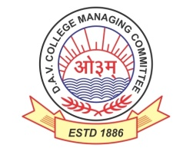

DAV HZL Sr. Sec. School dariba

rajsamand (raj.)

DAV HZL Sr. Sec. School dariba, rajsamand(raj.)

Split-up Syllabus

Class- III

Split-up Syllabus & Activities

for the session

2024-25

Class-XII (Comm.)

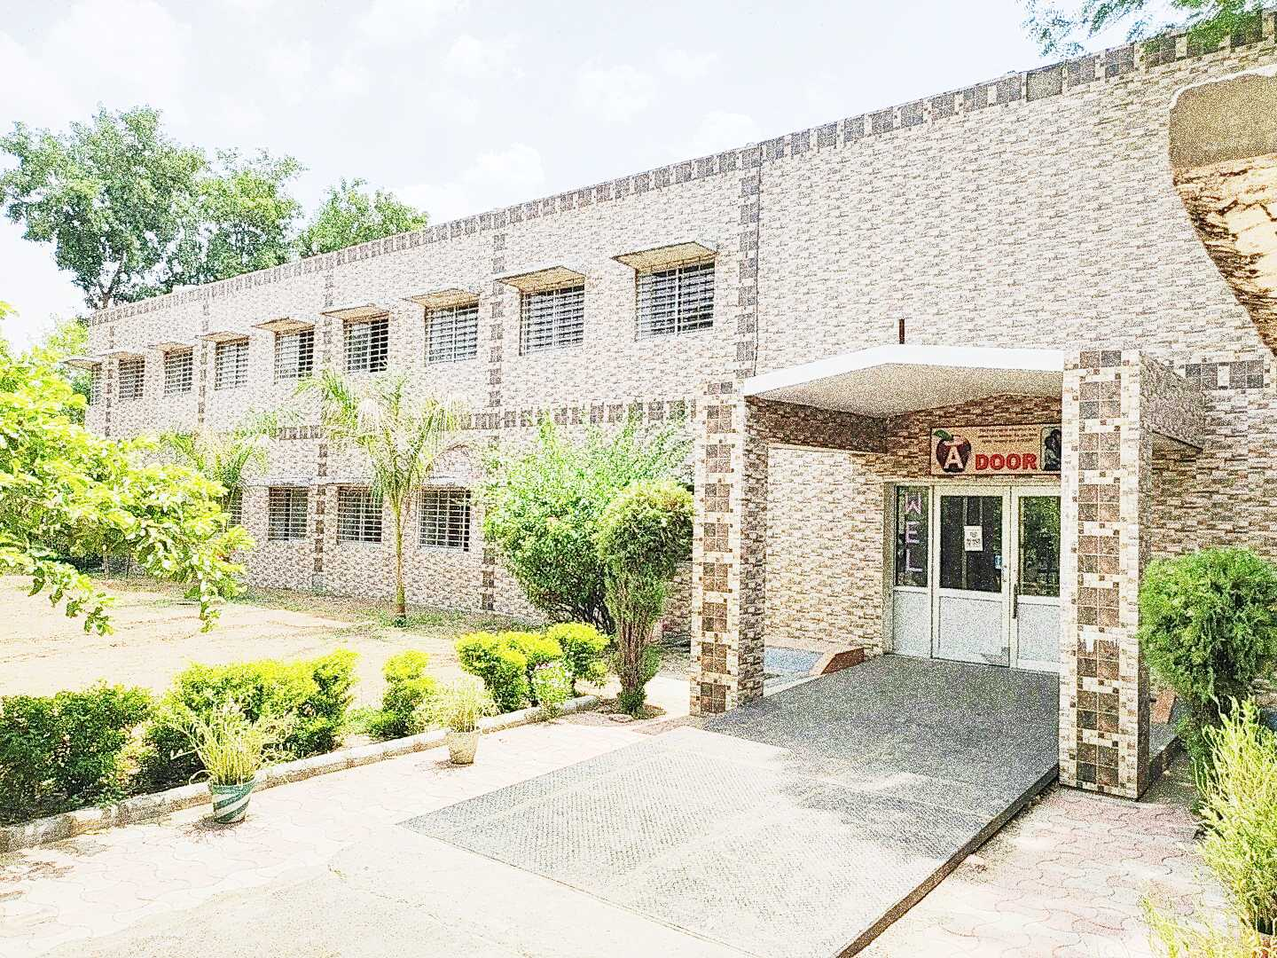

Address : Rajpura-Dariba, Distt. – Rajsamand (Raj.) 313211

Contact : (02952)265130 Email : davhzl_dariba@yahoo.com Website : www.davhzldariba.in

|  |  |  |
| --- | --- | --- |
| **Subject** | **UT- I** | **UT- II** |
| **English** | The Last Lesson, My Mother at Sixty Six, Notice Writing | Lost Spring ,Deep Water, Keeping Quiet ,A Thing of Beauty, The Third Level, The Tiger King, Formal/Informal Invitation and Reply |
| **Accountancy** | Ch. – 1 &2 | Ch. – 2,3& 4 |
| **Economics** | Macro Economics Unit – I & 2 | Macro Economics Unit – III & IV |
| **Maths** | Ch. – 2,3, 4 | Ch. – 1, 5 |
| **Business St.** | Ch. – 1 to 2 | Ch. – 3, 4, 5 |
| **Physical Education** | Unit – I & II | Unit – III & IV |

|  |  |  |
| --- | --- | --- |
| **Subject** | **Mid Term** | |
| **English** | The Last Lesson, Lost Spring, Deep Water, The Rattrap, My Mother at Sixty-Six, Keeping Quiet, A Thing of Beauty, The Third Level, The Tiger King, Journey to the end of the Earth, The Enemy, Notice Writing, Formal/Informal Invitation and Reply, Letter Writing | |
| **Accountancy** | Unit - I & II (Company Accounts) | |
| **Economics** | Macro Economics Unit-1 to 5 | |
| **Maths** | Ch. – 1, 2, 3, 4, 5, 6 | |
| **Business St.** | Ch. – 1 to 8 | |
| **Physical Education** | Unit – I to V | |
|  |  | |
| **Subject** | | **Pre Board and Final Term syllabus as per CBSE** |
| **English** | | Complete course as per CBSE Board |
| **Accountancy** | | Complete course as per CBSE Board |
| **Economics** | | Complete course as per CBSE Board |
| **Mathematics** | | Complete Course as per CBSE |
| **Business St.** | | Complete course as per CBSE Board |
| **Physical Education** | | Complete course as per CBSE Board |

|  |  |
| --- | --- |
| **Exam** | **TENTATIVE DATES OF EXAM** |
| **UT – I** | First Week of May 2024 |
| **UT- II** | First Week of August 2024 |
| **MID – TERM** | Third Week of September 2024 |
| **Pre-Board-I** | Second Week Of December 2024 |
| **Pre-Board -II** | January 2025 |
| **FINAL TERM** | As per CBSE Board |